# Virtual Machine Creation

Steps to create a Virtual Machine in Azure:

1. Login to Azure portal and tap on create virtual machine and you will see me below image and enter the required details.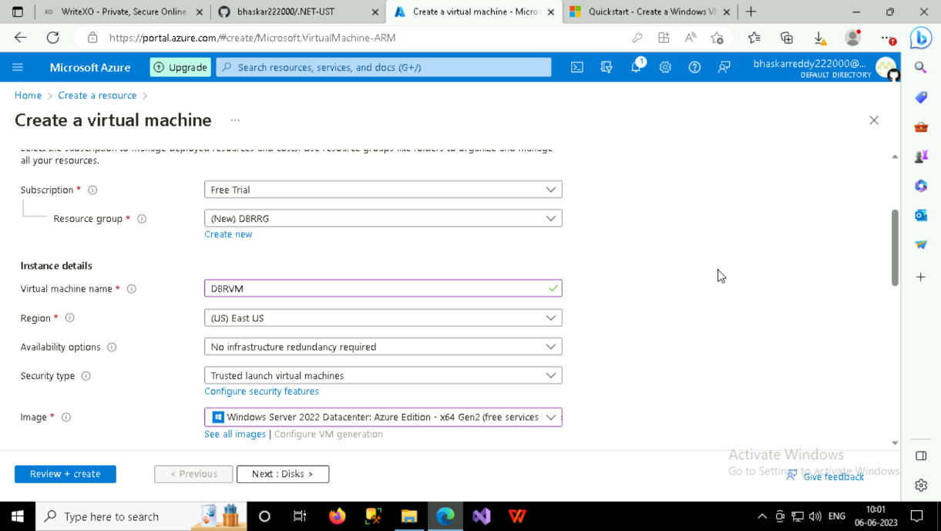
2. Remember the username and password you have entered. 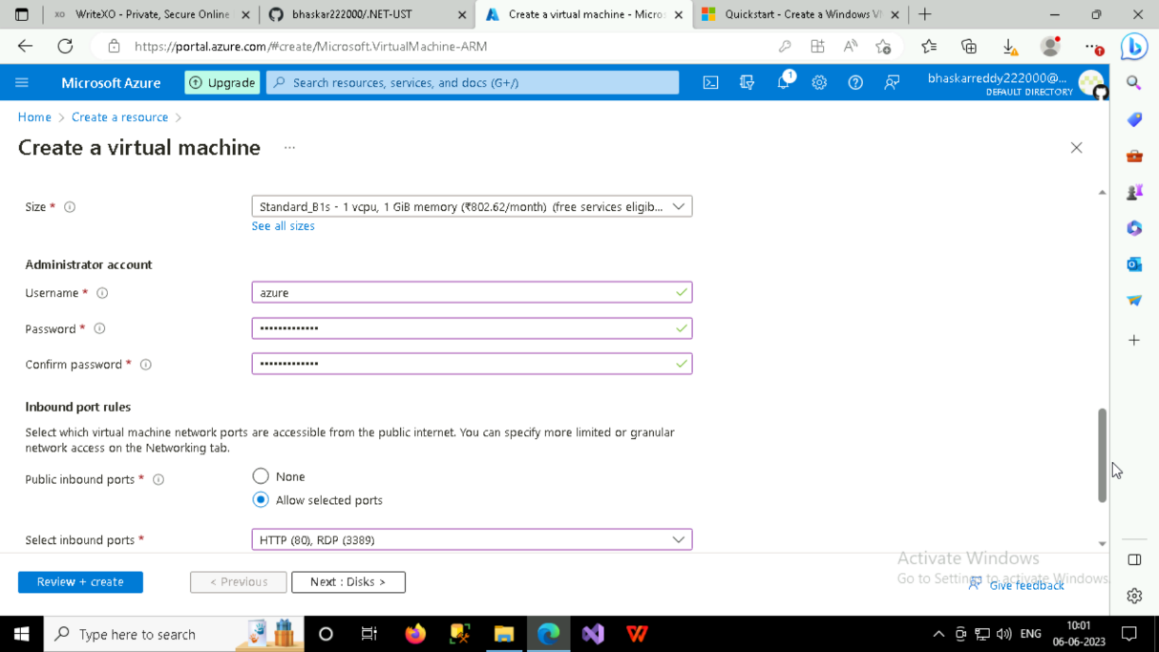
3. After step2, you can skip the next box and tap on create and review. You will get below image after validation passed and tap on create.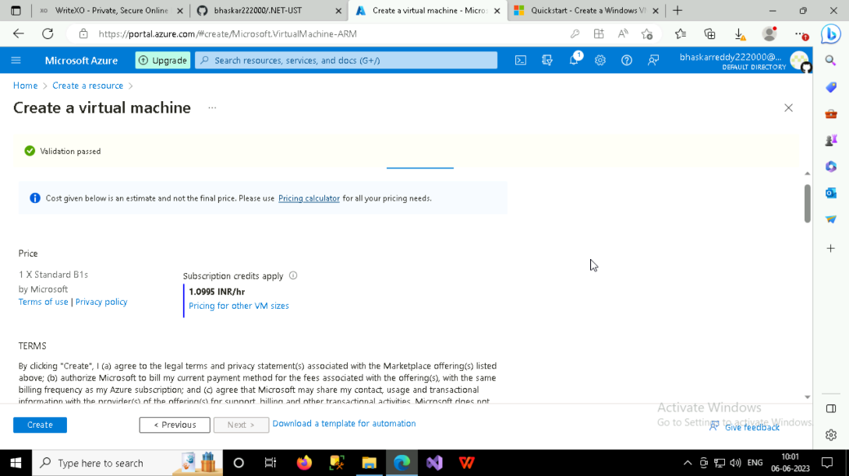
4. After that your deployment is created and tap on Go to resource and you will get next page shown in below image. There you need to tap on connect. A screenshot of a computer

   Description automatically generated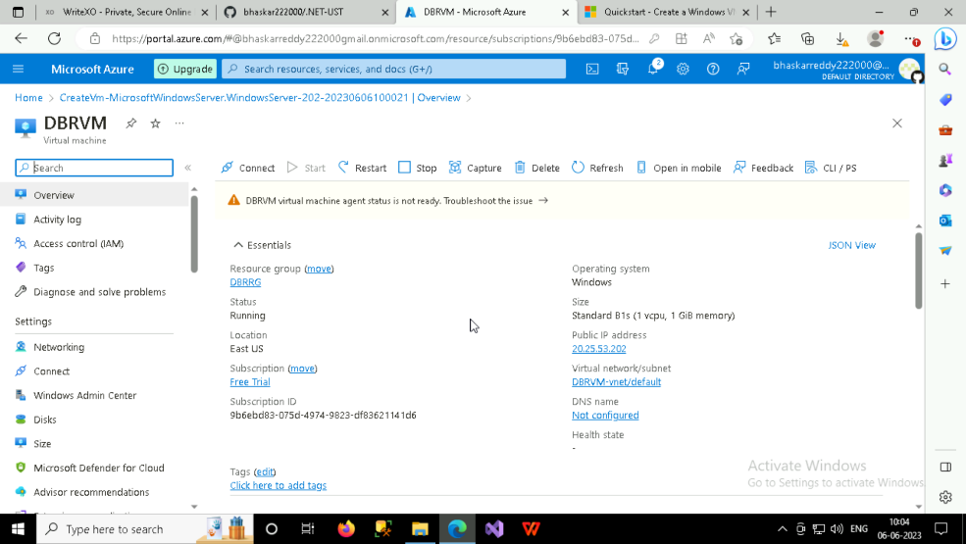
5. After tapping on connect you will get the below image and you need to download RDP file. As shown in image open the downloaded file.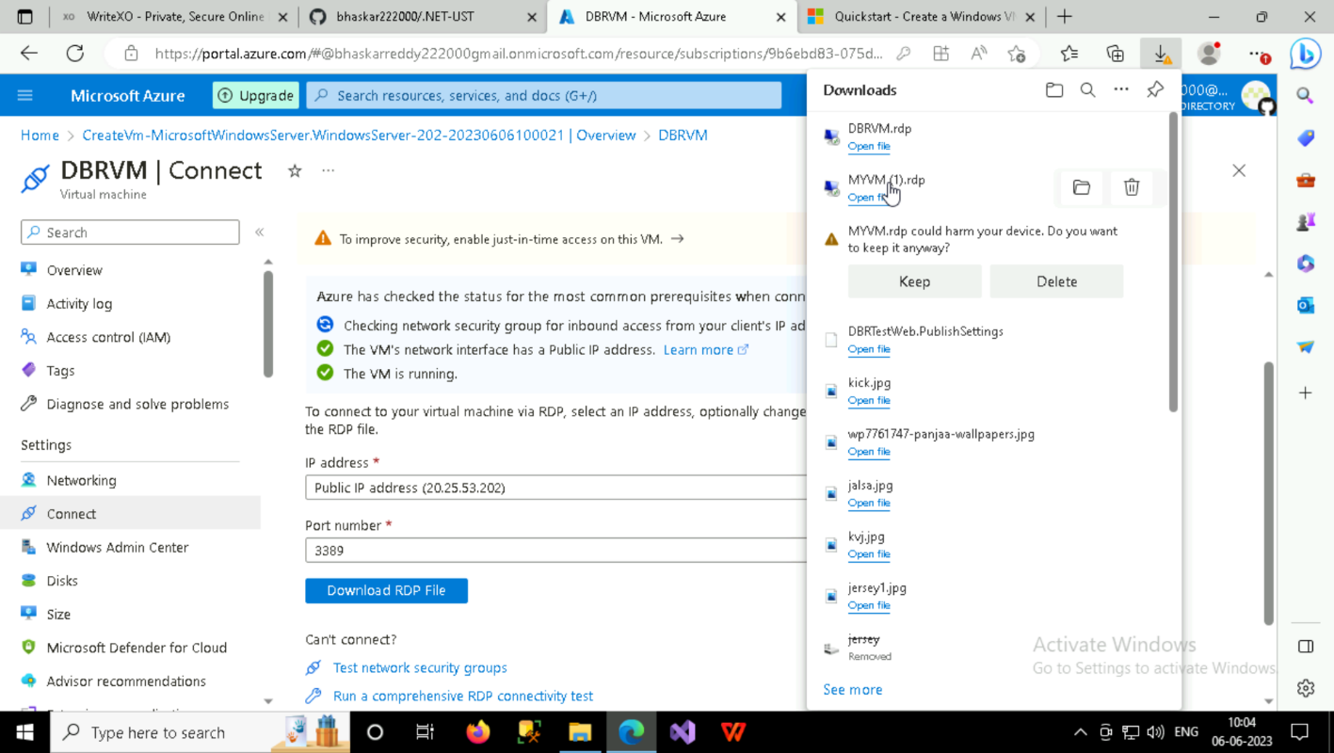
6. After opening the downloaded file, you will get the dialog box where u need to tap on connect.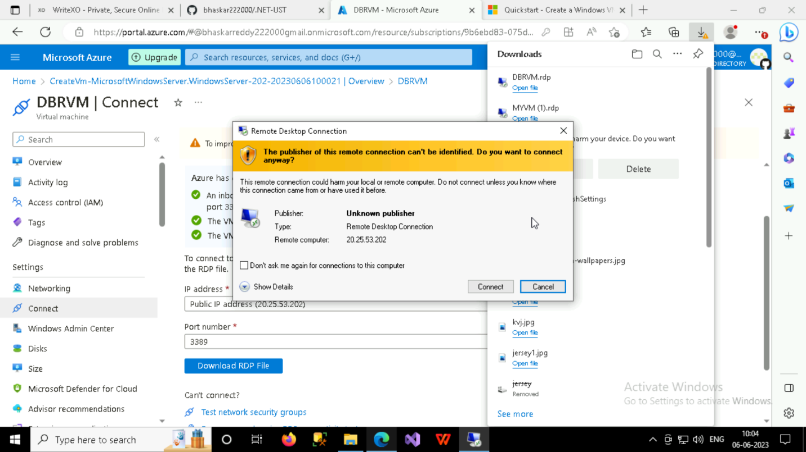
7. After connecting, you will need to enter the username and password which you earlier created.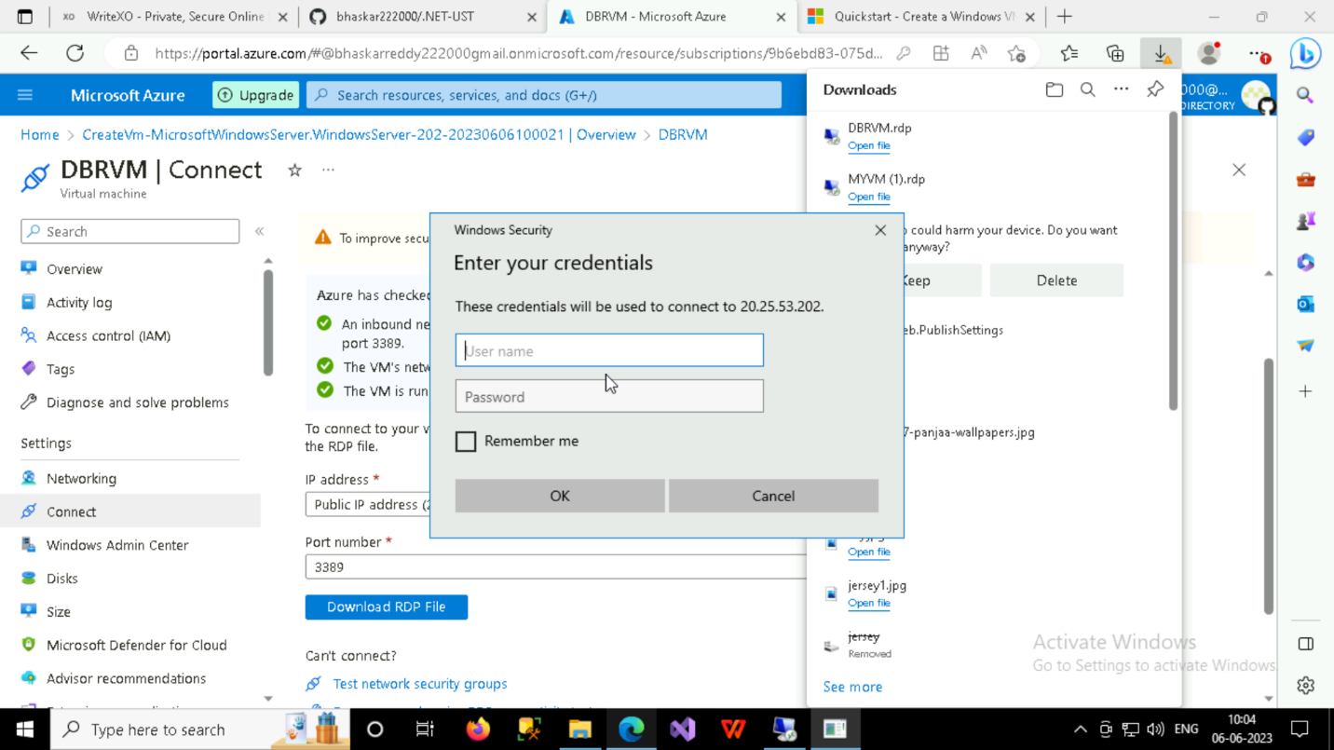
8. Your VM is created.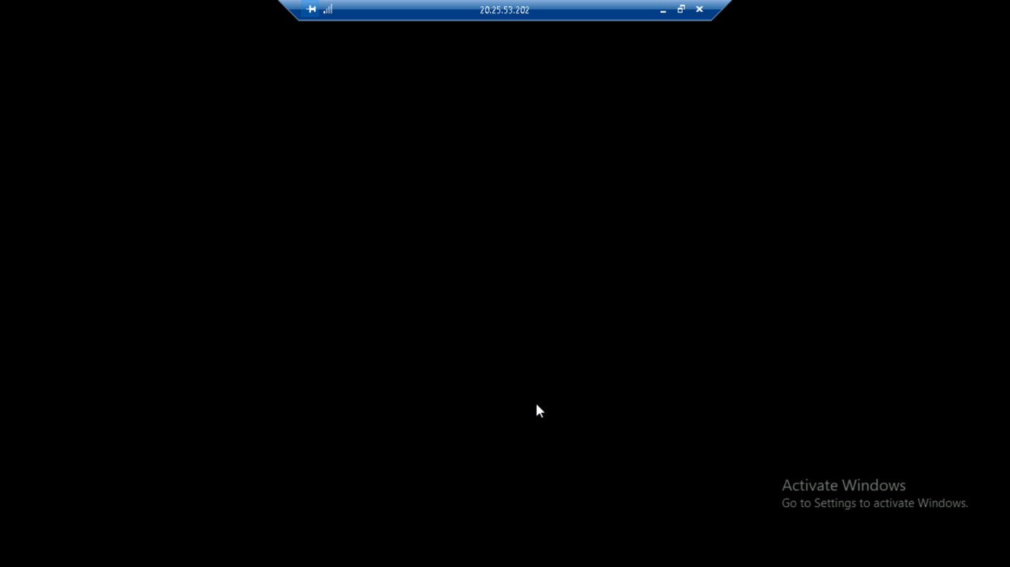
9. When VM is created, and you are not using delete the resource which you created in Azure portal. So that your money will be saved.